PureData file download: https://drive.google.com/file/d/1wxj_5478UpnZ7wOuanvPrJ0Qe4NMcgxJ/view?usp=sharing
- Introduction
Don Buchla was an American electronic music instrument designer and a key figure in the development of electronic music. He was known for creating innovative and experimental electronic instruments that pushed the boundaries of traditional music making. His instruments were influential in the early development of electronic music, particularly in the 1960s and 1970s. Some of his most famous creations include the Buchla 100 series, Buchla Music Easel, Buchla 200 series, and the Buchla Thunder. Buchla's synthesisers differed from the classic subtractive synthesizers popularized by Robert Moog. It offers a unique and experimental approach to sound synthesis. His work in analog synthesis and electronic instrument design has left a lasting impact on the world of electronic and experimental music. His instruments have continued to be used and sought after by musicians and sound artists, and his legacy lives on through the ongoing development of his synthesizer designs by companies and enthusiasts dedicated to preserving his contributions.

Among his creations is Buchla 700, an inspiring synthesizer that unfortunately didn’t find its place on the market. Utilizing FM Developed by John Chowing, Yamaha’s DX 7 quickly became one of the most influential and best selling synthesizers. Influenced by the synth trends in the 1980s, Buchla 700 is also heavily based on FM and waveshaping for its sound generation. Compared to the 4 oscillator synthesizers from Yamaha such as the tx81z, which was released in the same year, Buchla 700 offers something unique and intriguing. One of the highlights of the Buchla series is timbre modulation, which was unique to Buchla’s instrument at the time[2]. The detailed control on the oscillators and indexes are fun to play with and it allows its user to create complex and unique sounds. It is perhaps one of Don’s most complicated designs, offering 12 voices with 12 different configs.

Because of its comprehensiveness and the scarcity of this design (also its unacceptable price), I decided to recreate this synthesizer in software for the purpose of learning and practicing.
- Overview

I decided to use pure data as my tool for recreation because of its affordability and the amount of resources online. The functions and descriptions that it provides makes it easier to learn and more time efficient. This recreation took information and inspiration on ID700, which is a synthesizer based on the voice architecture of the Buchla 700[3], and the user guide to Buchla 700, which discusses the architecture in detail.

Each voice in Buchla 700 is capable of generating a wide range of sounds through the use of up to 4 oscillators. These oscillators can be directly mixed to create the final output or modulate one another to introduce complex and dynamic soundscapes. Signals from the oscillators are then routed with 6 indexes that can control its amplitude and modulation intensities. In the original design of Buchla 700 these signals are then routed to two wave tables(which are not present in this design).

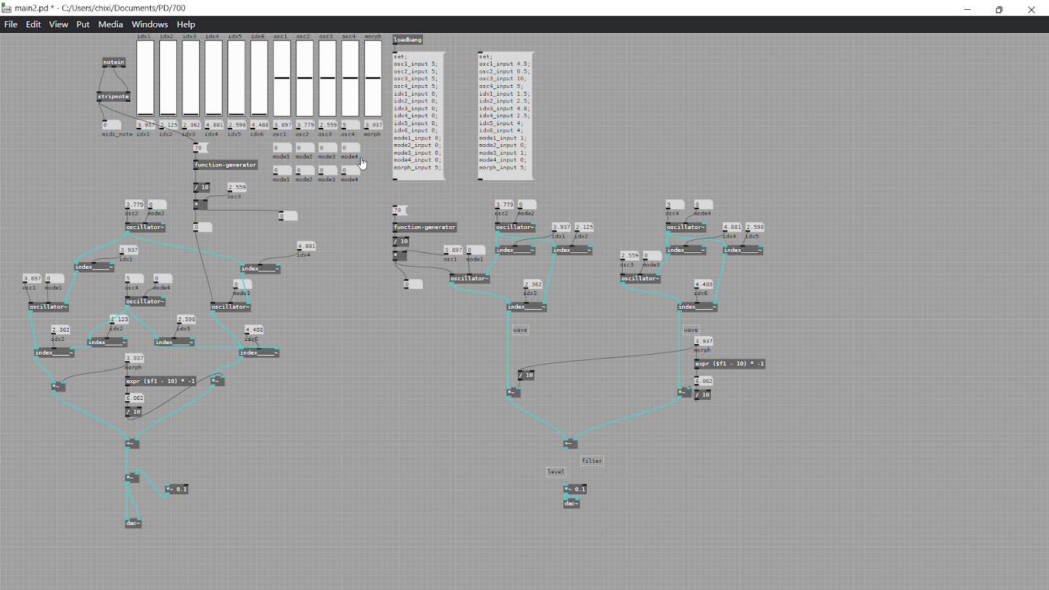
At the end, an equal-power fader between the outputs will morph the signals generated by the interconnection of two series of oscillators and the indexes. (Originally between the outputs of Wave table A and Wave table B)

- Algorithm
The original design of Buchla 700 contains 12 different layouts of oscillators and indexes.
My software version however currently only covers two.
- Oscillator connected perpendicular to oscillator offers Frequency Modulation
- Indexes connected to Indexes offers Timbre Modulation
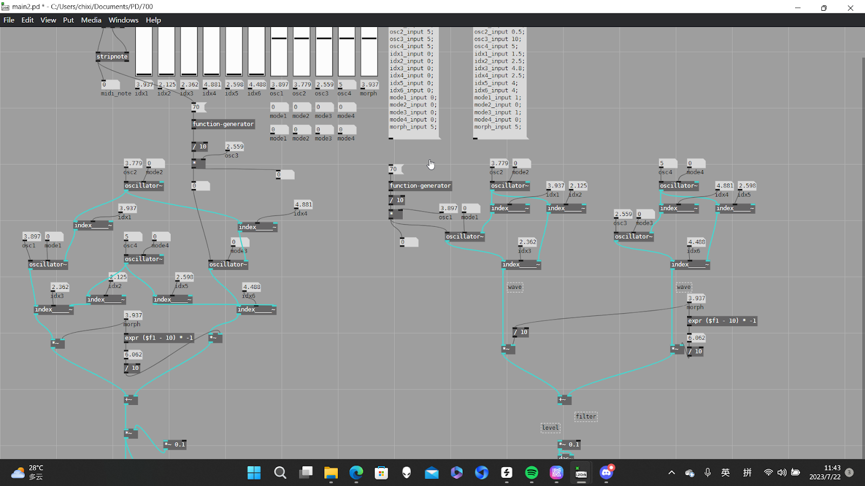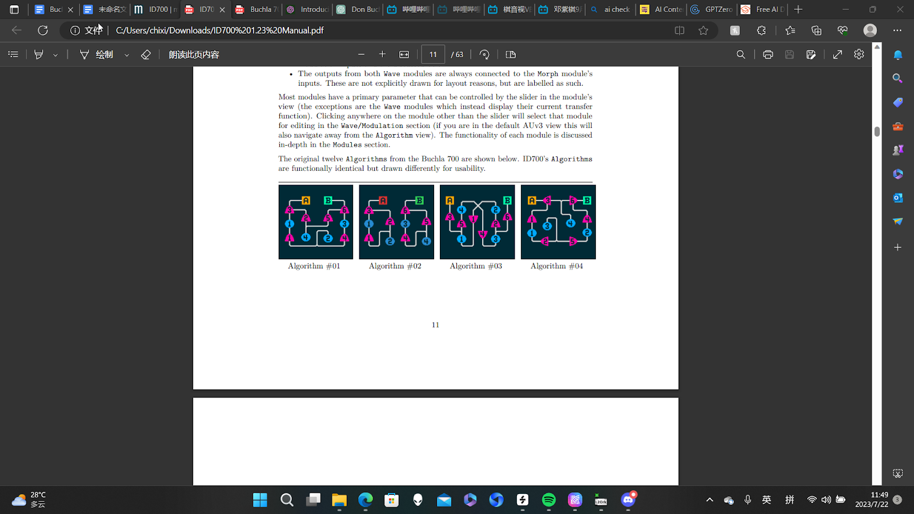
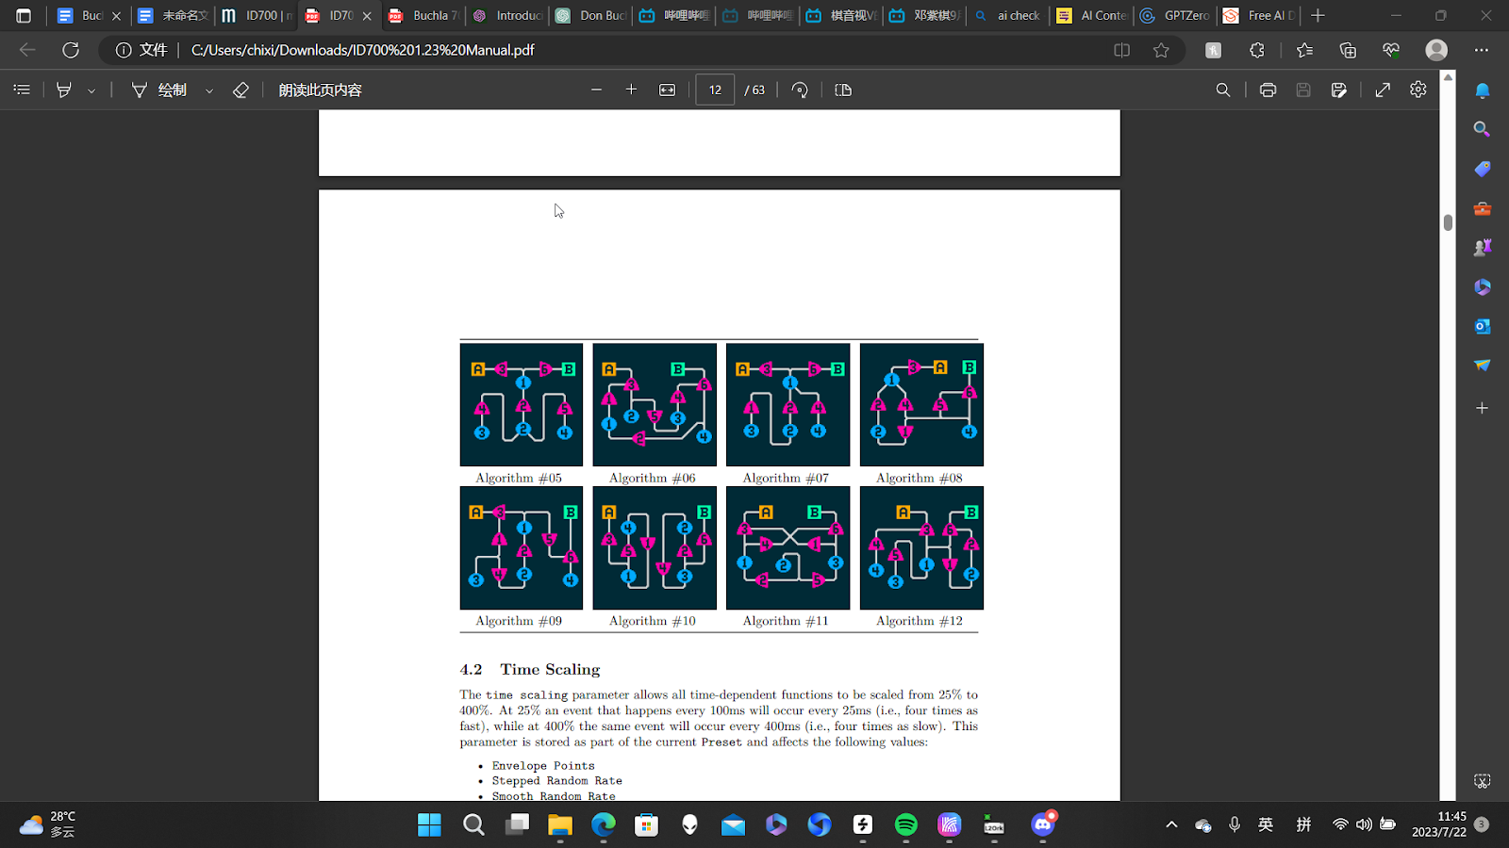

4. Overview of Oscillator Modes
The oscillators in Buchla 700 can operate in three different modes: Interval, Ratio, and Frequency, and I tried to recreate them in software.
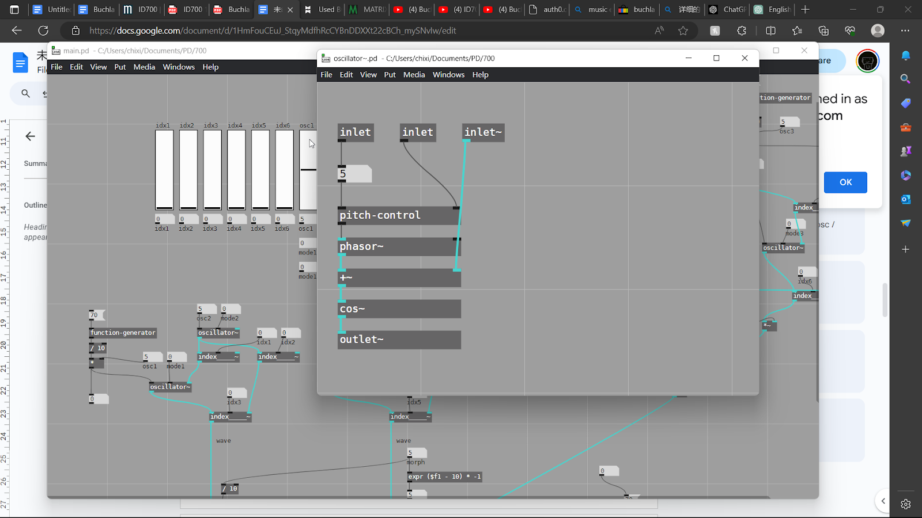

3.1 Interval Mode
In Interval mode, the frequency of each oscillator is determined by the incoming MIDI note's frequency offset by the slider value. Use the slider to adjust the frequency within a range of +/- 2 octaves (+/- 2400 cents). (See Fig 1)

3.2 Ratio Mode
In Ratio mode, the frequency of each oscillator is determined by the incoming MIDI note's frequency multiplied by the slider value. Adjust the slider to set the frequency within a linear range of 1/16-8/1 (rational numbers). (See Fig 2)

3.3 Frequency Mode
In Frequency mode, the oscillator ignores the pitch of incoming MIDI notes. Instead, the slider sets the frequency in a sub-audio range of 0.1mHz-16.636Hz. This mode primarily functions for modulation purposes. (See Fig 3)
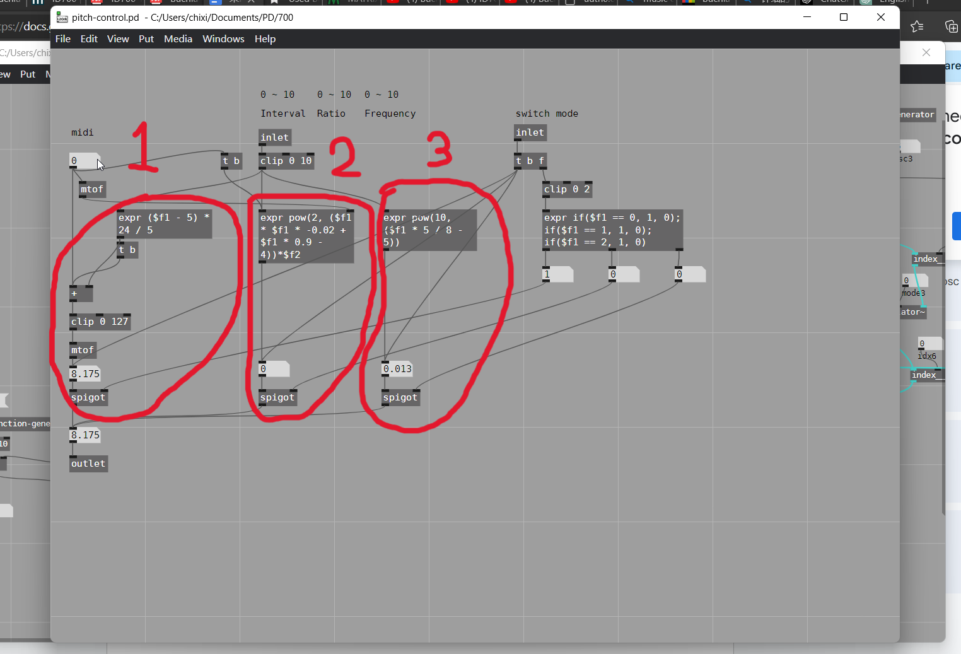

- Overview of Indexes
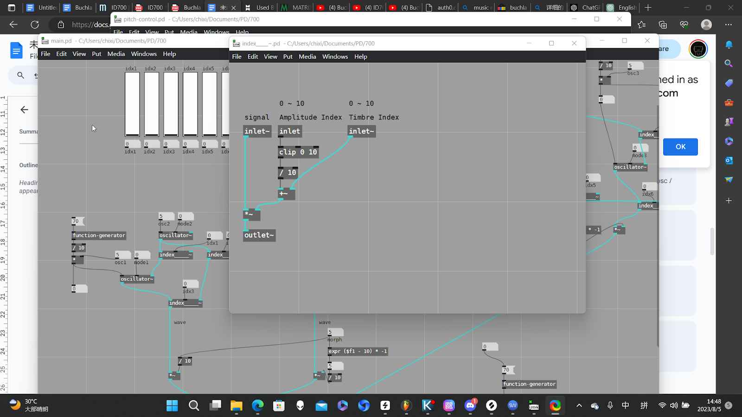
4.1 Amplitude index
These Indexes control the amplitude of the signal entering the morph module. Amplitude refers to the strength or intensity of the signal.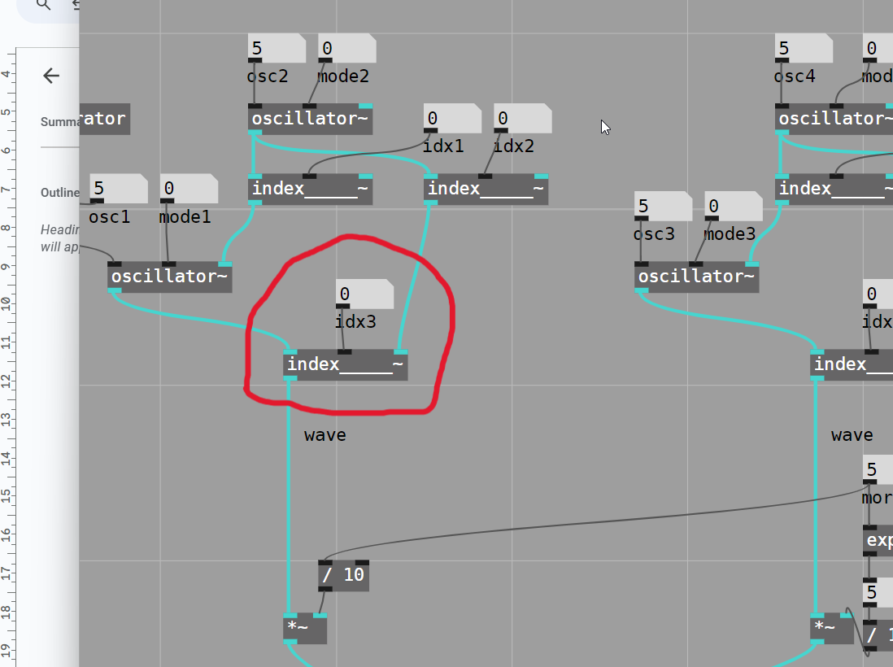

4.2 Timbre index
Timbre Indexes serve as connections between an oscillator's output (modulator) and an Amplitude Index's input (carrier). Their primary function is to modulate the level of the Amplitude Index, without actually increasing the carrier signal's amplitude. Unlike traditional amplitude modulation (AM), the Timbre Index multiplies the Amplitude Index's level by a phase-shifted version of its own output.

When the connected Wave module uses a Waveshape with a single harmonic, the resulting output will resemble conventional amplitude modulation. However, if multiple harmonics are involved, the sound becomes more complex and rich in harmonics. This creates a diverse and harmonically-rich sound, adding depth and character to the audio.
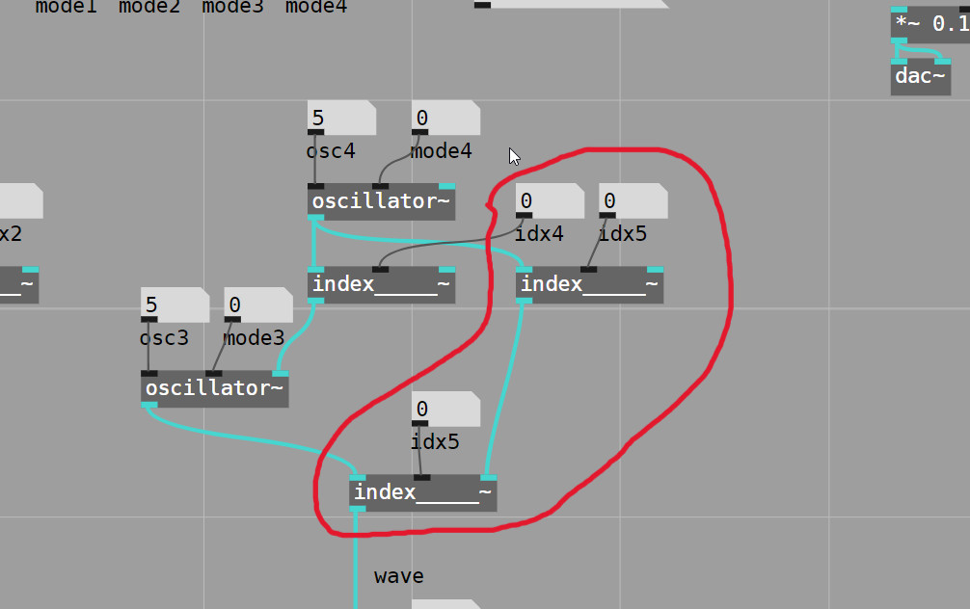
4.3 Frequency index
Frequency Indexes are placed between an oscillator's output (modulator) and another oscillator's input (carrier). These Indexes control the modulation index of the modulator applied to the carrier. Modulation refers to the process of varying one parameter of a waveform (the carrier) with the signal from another waveform (the modulator). When the Frequency Index value is set to zero, no modulation occurs, and the carrier oscillator's frequency remains constant. As the Frequency Index value is increased, the amount of modulation on the carrier oscillator also increases, causing the frequency to fluctuate based on the modulator's output.
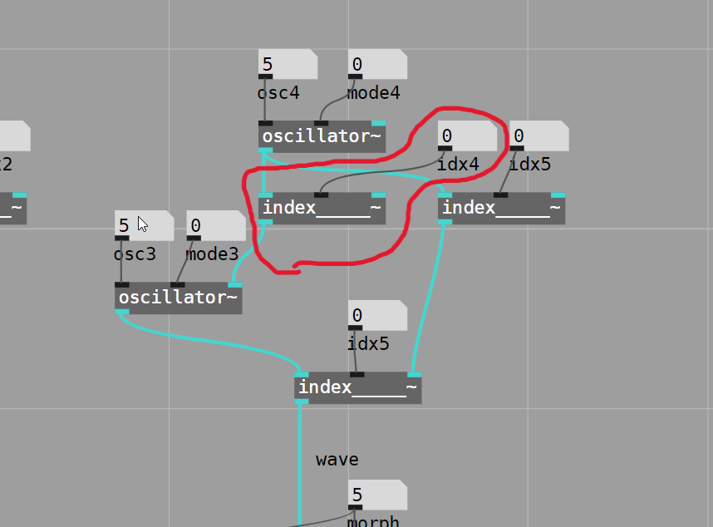

- Morph
The signals generated by the oscillators and the indexes originally are routed to two wave tables. Instead they are now directly connected to the Morph module. This offers control to the final output composed of the mix of two series of signals.

